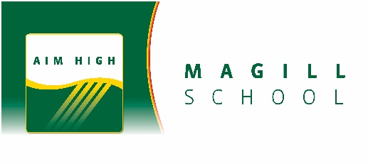

General Information for Magill School Specialist Programs
Magill School offers Specialist Programs for Reception to Year 6 students. A brief explanation of each Specialist Program and the staff responsible for delivering them is included below.

Science
Science is an inspiring, engaging, and enjoyable subject which provides countless opportunities for students to explore how the world works. It is taught as a specialist subject R-6. Each weekly lesson is a double block which is 100 minutes in length.
The students will engage in science learning through an inquiry cycle which includes ‘hands on’ activities, experiments, investigating, individual/group work, report writing and data collection, researching and reflecting on aspects of their learning. The focus is on providing opportunities to allow students to understand the curriculum and connect this to real world experiences. Students will be assessed throughout the term with feedback being given verbally and in writing about their effort and achievement. There will be comments included in both the Term 2 and Term 4 reports alongside Achievement and Effort grades.
Students will engage in learning from the three strands of the curriculum, which include:
- Science Understanding: Physical, Biological, Chemical and Earth and Space Sciences
- Science as a Human Endeavour
- Science Inquiry Skills

Schona Murray | Science R-2  Monday, Tuesday, Wednesday, Thursday  schona.murray461@schools.sa.edu.au | 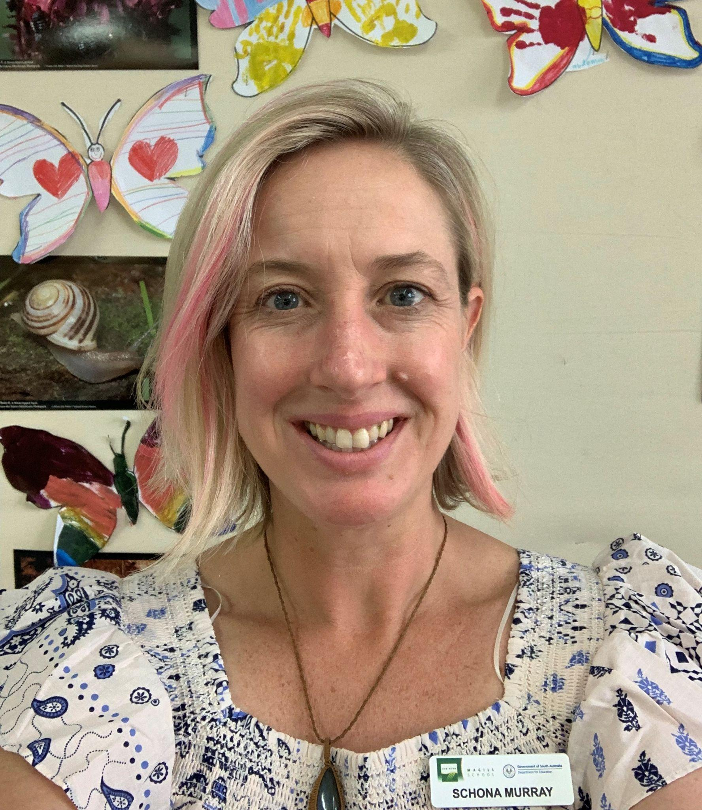
Sophie Tarney | Science R-2  Tuesday, Wednesday  sophie.tarney390@schools.sa.edu.au | 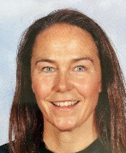
Beck Phillips | Science Years 3-5  Tuesday - Friday  rebecca.phillips434@schools.sa.edu.au | 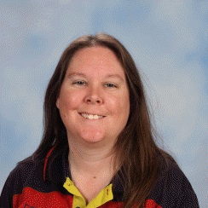
Danielle Bator | Science Years 5-6  Tuesday, Wednesday, Thursday  danielle.bator749@schools.sa.edu.au | 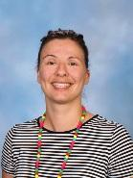

Chinese (Mandarin)

Chinese is offered as a Second Language programme and the general aim of the programme is that students of Chinese and non-Chinese background learn to communicate effectively in Chinese, in real-life situations, appropriate to the age group.
All students will develop listening, speaking, reading, writing and cultural understandings during their lessons.
Reception and Year 1 students participate in one 50-minute lesson a week.
Years 2 – 6 students participate in two 50-minute lessons a week.
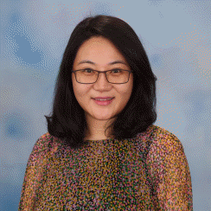
Ivy Liu Year 4 – 6
Works Tuesday-Friday
Email: Yingnan.Liu988@schools.sa.edu.au

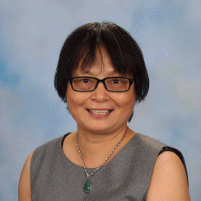
Min Mu: R – 2
Works Monday, Wednesday and Thursday
Email: min.mu96@schools.sa.edu.au

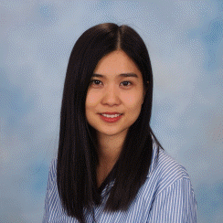
Mai Xie: Reception, Year 3 and Year 4
Works Tuesday - Thursday
Email: maimai.xie510@schools.sa.edu.au

Performing Arts (Music, Dance and Drama)
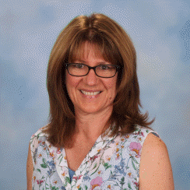
Georgea Champion: Reception—Year 3 Music/ Dance/ Drama
Works Monday-Thursday
Email: georgea.champion443@schools.sa.edu.au

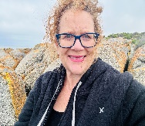
Milda Fahey: Reception-Year 1 Drama /Media Arts Performing Arts Years 4-6
Works Monday-Friday
Email: milda.fahey247@schools.sa.edu.au

Lessons are interactive, practical, energetic and engaging, aimed to:
- Develop skills and knowledge, a positive mindset and self-image through creating, critiquing and performing Music, Dance and Drama.

During the year, students have opportunities to perform items at assemblies and special events.
Reception – Year 6 students participate in an End of Year Concert that runs in a
3-year cycle: Australiana Bush Dances and Songs, A Multicultural Celebration and Christmas and A Festive Celebration.
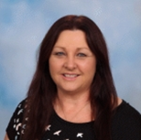
Choirs:
- The Year 2 & 3 choirs practise on Thursday with Georgea
- The Year 4 choir practise on Thursday with Deb
- The Year 5/6 Senior Festival Choir, conducted by Deb, practises on Friday
afternoons.
Physical Education
The program allocates one lesson for P.E. per week for each class R-6.
The program aims to:
- Provide students with opportunities to explore and develop movement skills, understand movement and learn through movement.
- Offer students a quality environment to interact and contribute to a safe and active community being socially involved at different levels and in different groups.
- Support students to develop sportsmanship, optimism and positive attitude, friendship and team-work.
- Provide opportunities to all students to explore their favourite skills and develop interest in playing sport outside school for long term (e.g. local sporting clubs)
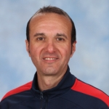 | 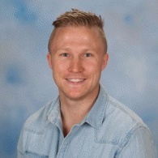
Florin Velea  florin.velea226@schools.sa.edu.au  Reception to Year 4 (Yr. 4`s - F8 and F9)  Working Tuesday, Wednesday, Thursday and Friday | Andy Read  andy.read416@schools.sa.edu.au  Year 4, 5 & 6 (Yr. 4’s – F10 & F11)  P.E - Tuesday and Wednesday  Classroom - Thursday

EALD (English as an Additional Language or Dialect)

EALD Specialist teachers support children who are from a non-English speaking background focusing on language learning. They create a supportive and caring environment to encourage the development of English by working either in class or with small groups of children with high language needs. The students in these groups are selected by their classroom teacher in consultation with the EALD teacher. Student oral and written assessments assist the team in making selections.

EALD teachers support EALD students in learning
- to speak
- to listen and understand
- to read and write in Standard Australian English - using English in different subject areas and in a variety of experiences

The EALD team at Magill are:
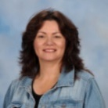
Mike Shortt: EALD Co-ordinator
Amanda Coad: EALD Teacher (Mondays, Tuesdays and Wednesdays)
Email: Amanda.coad901@schools.sa.edu.au
Michelle Stuart: Katherine Rideout: EALD Support Officers

Instrumental Music

Instrumental music education in SA government schools is organised by an education department program called Instrumental Music (IM). This program is offered to children from Year 4 and up.

Face-to-face lessons
Students participate in small group music lessons and learn to play an instrument through special programs run by DfE Instrumental Music teacher.

Ensembles
Students are able to participate in school ensembles, such as concert band and string ensembles.
Our Instrumental Music teachers are:
Monday Ian Seaborn
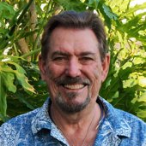
Classical Guitar
ian.seaborn272@schools.sa.edu.au

Peter Matzick
Percussion (untuned/tuned)
peter.matzick314@schools.sa.edu.au

Tuesday Nick Vladcoff
Brass (trumpet/trombone)
nick.vladcoff33@schools.sa.edu.au

Aaron Lipp
Woodwind (saxophone/clarinet/flute)
aaron.lipp94@schools.sa.edu.au

Wednesday Anne-Marie Meegan
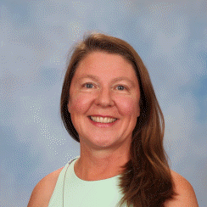
Strings (violin/viola)
Annemarie.meeganturner995@schools.sa.edu.au

Maria Foot
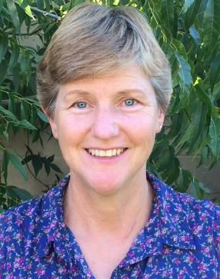
Cello/Double Bass
Maria.Foot731@schools.sa.edu.au

